**Output_ScreenShots_SportShoes**

1. Enter url- localhost:8082/SportShoes

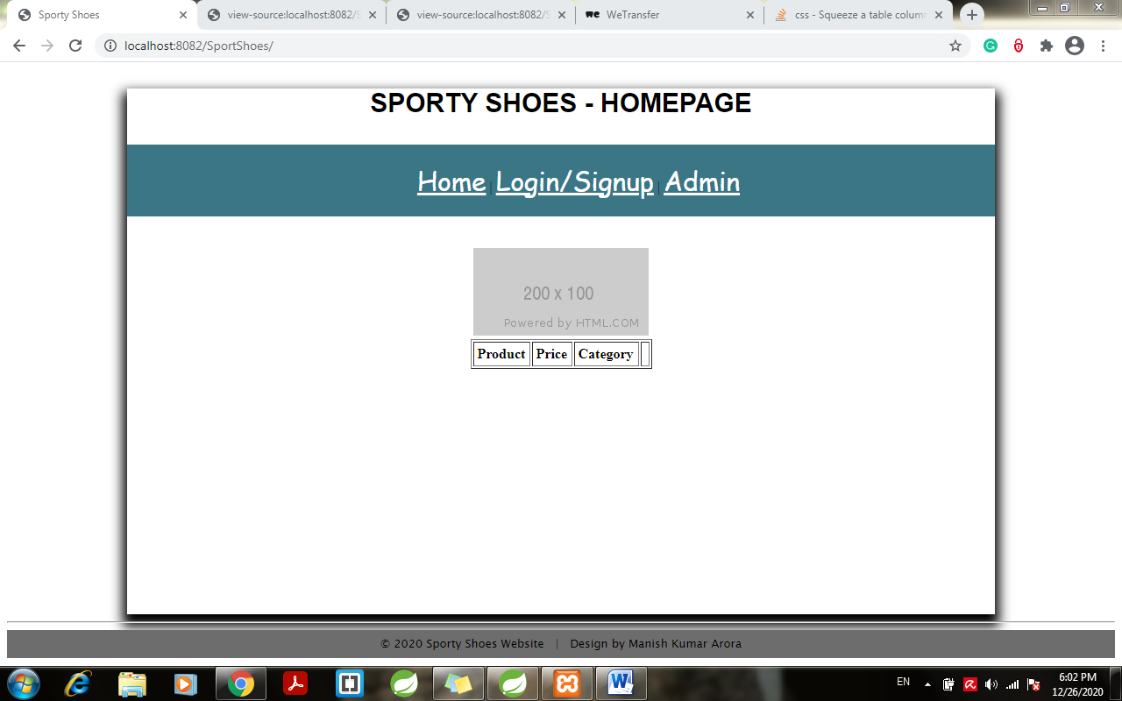

1. Click on home page: Menu Color changes to orange with use of style tags

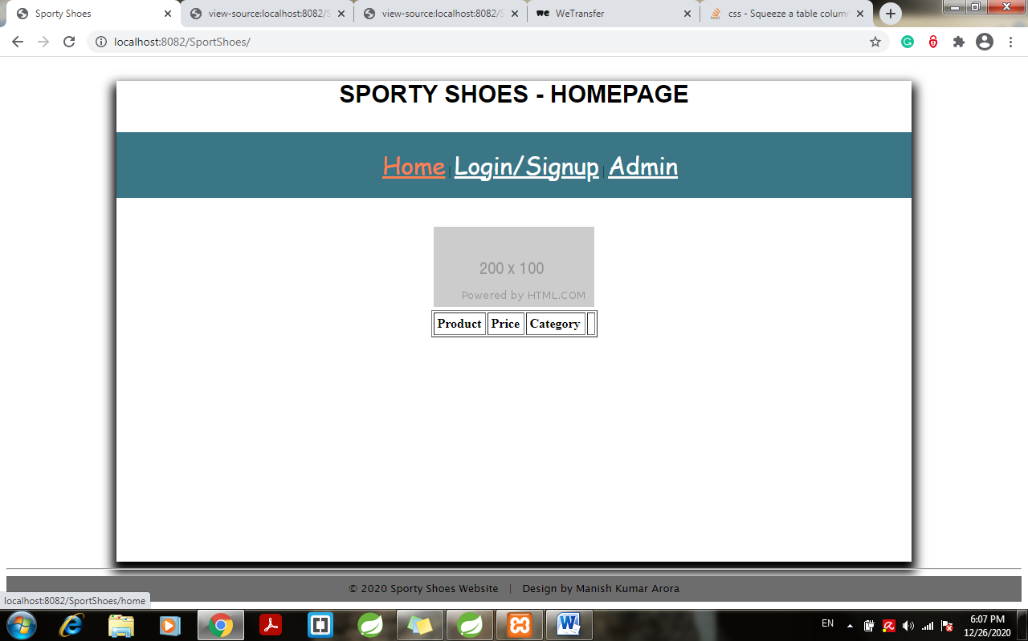

**Admin Login:**

1. Click on Admin> redirects to admin login page:

Admin id and password given in database initially was 12345 and admin:

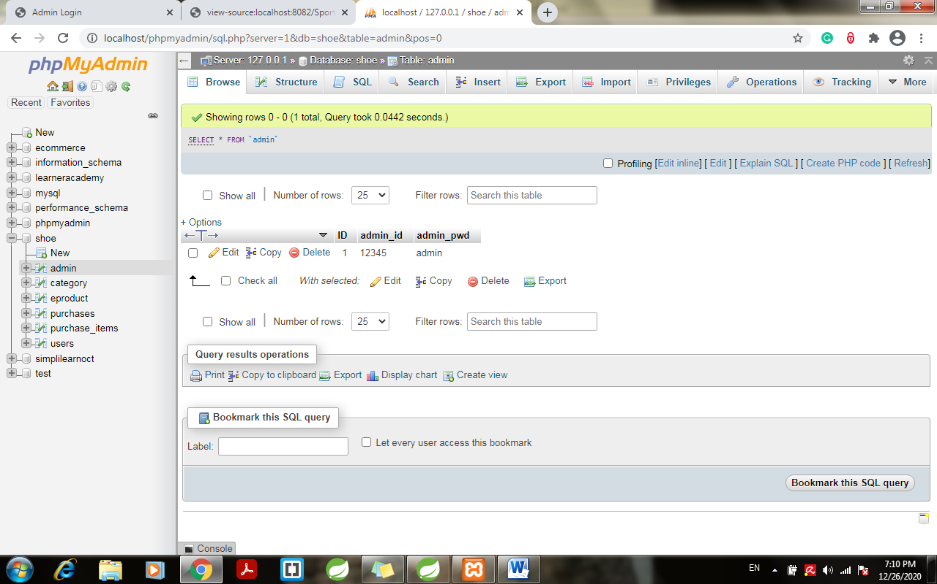

Enter above user name and password:

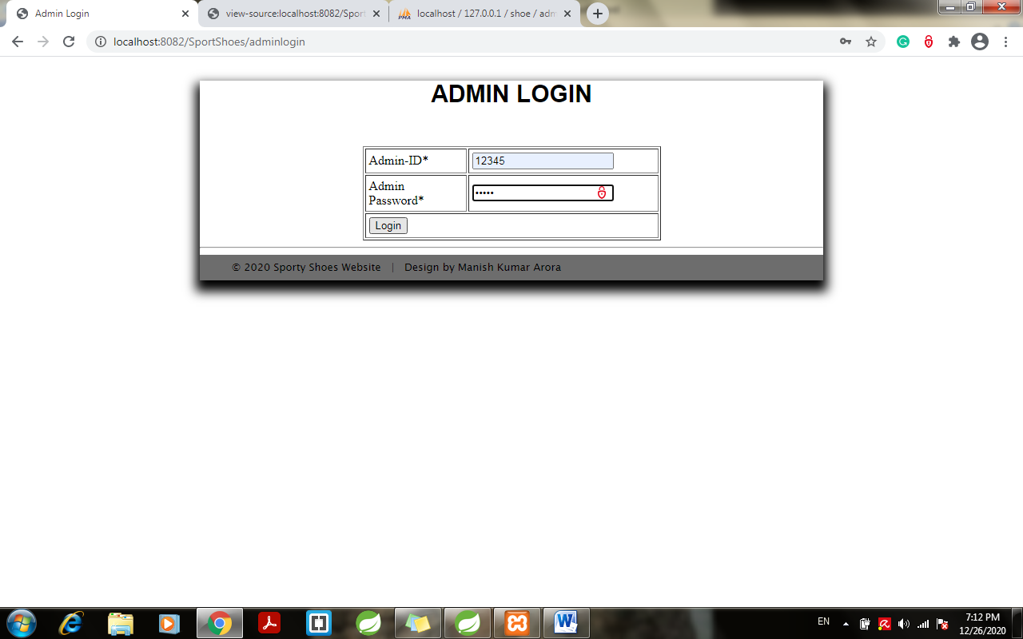

1. Click on login > redirects to admin dashboard:

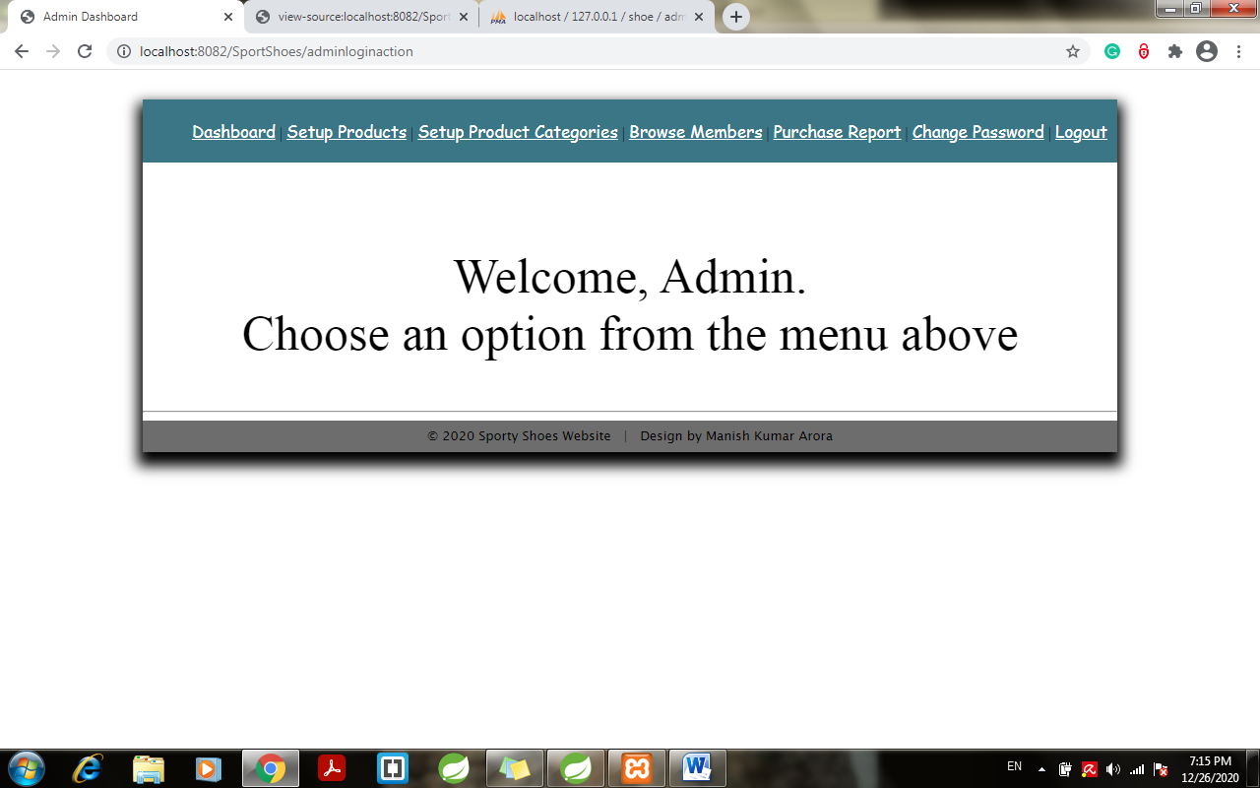

1. Click on Set up products category> redirects to admin set up product category page:

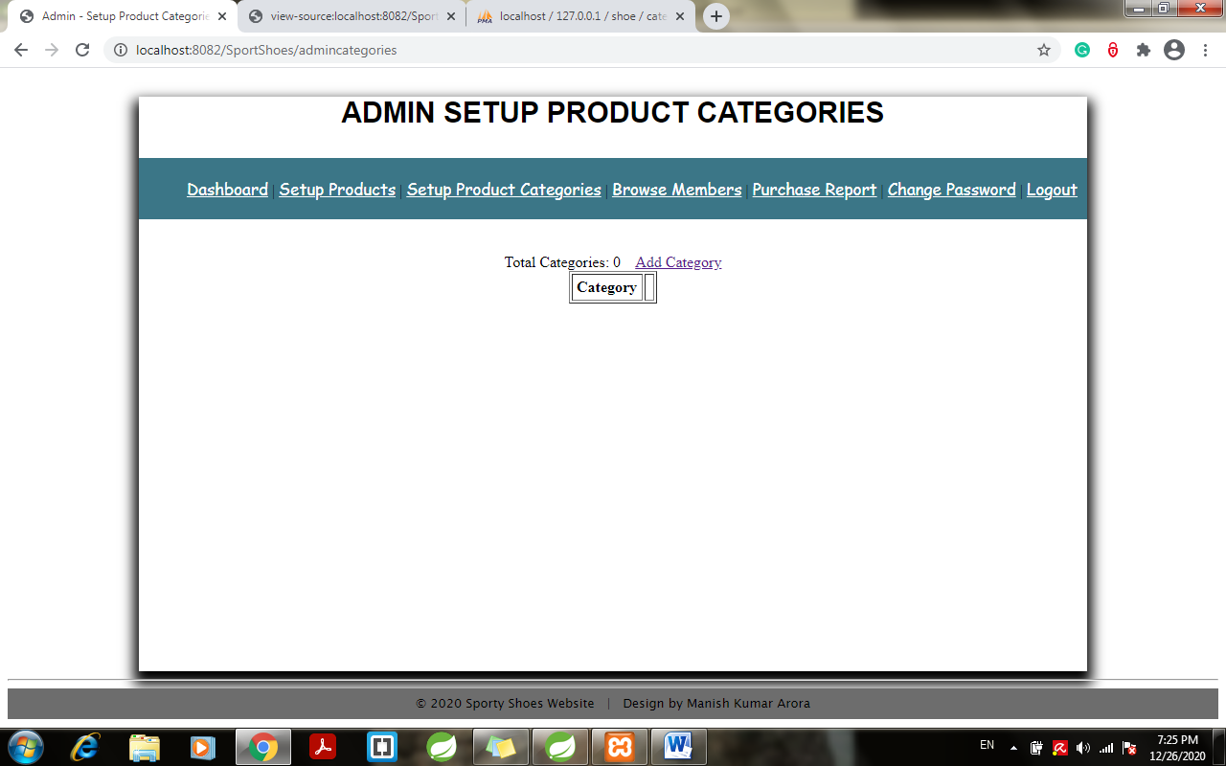

1. Click on add category > add category name:

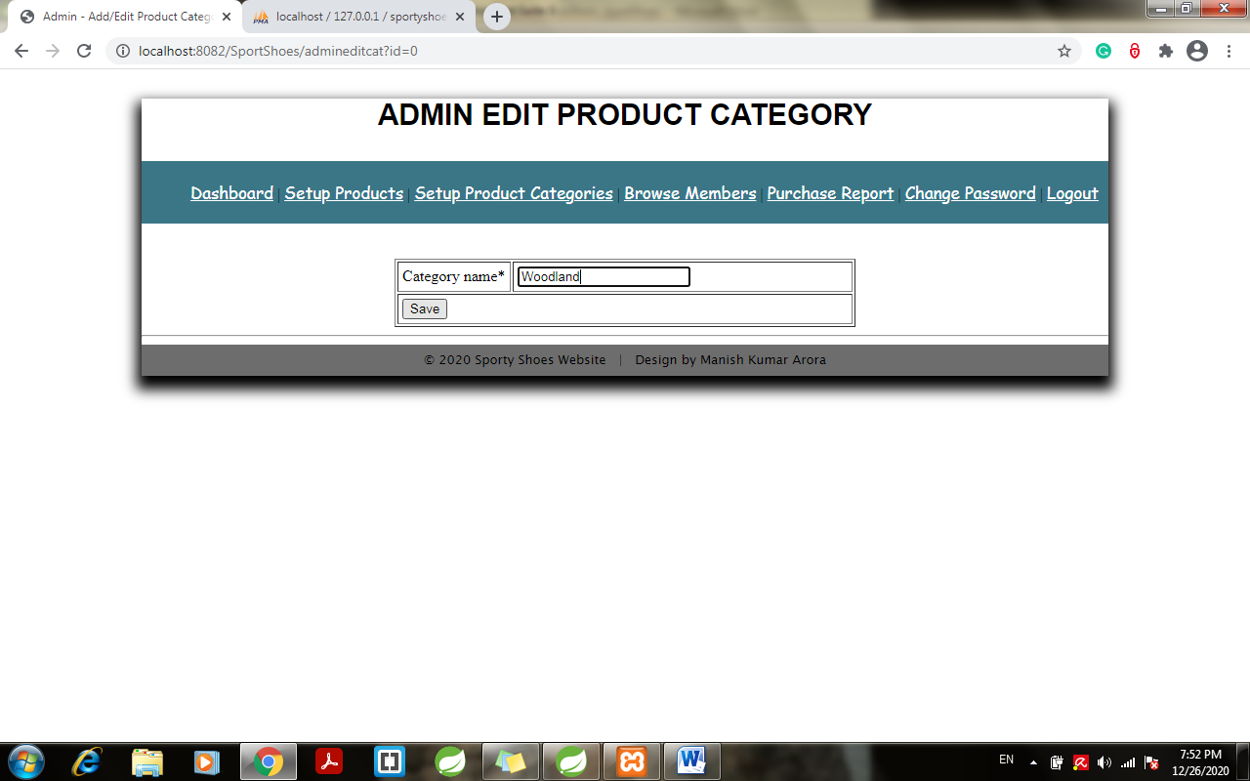

1. Enter Save > redirects to admin set up product category page:

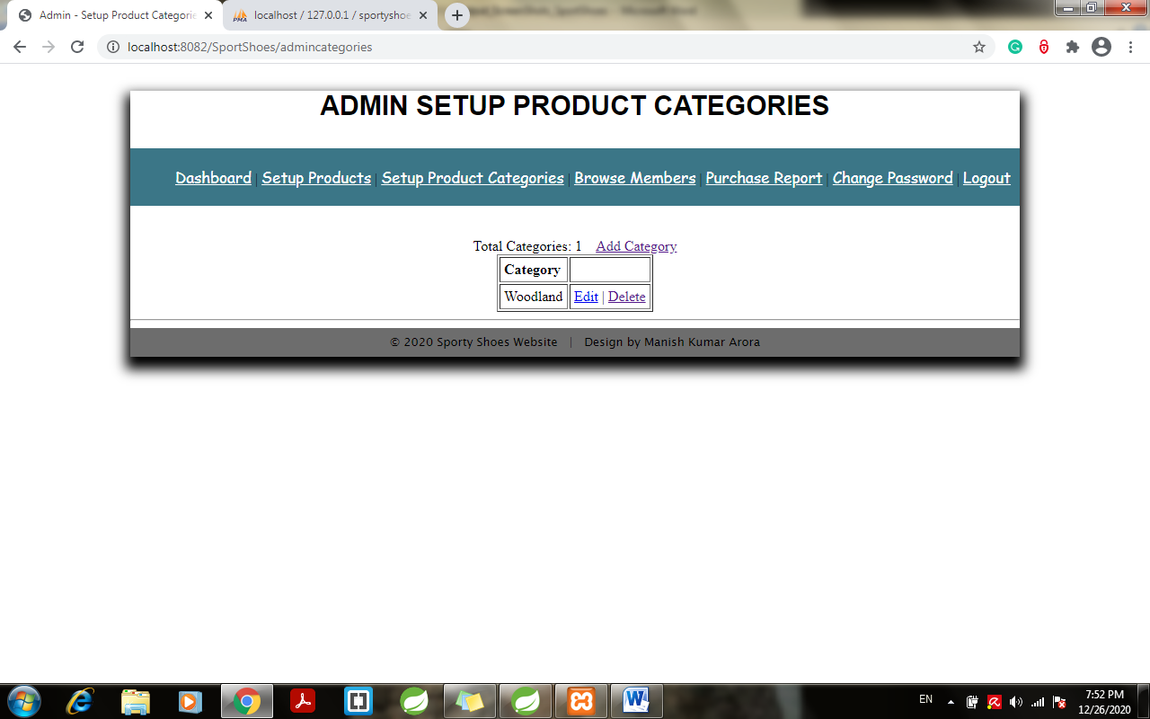

1. Click on set up products:

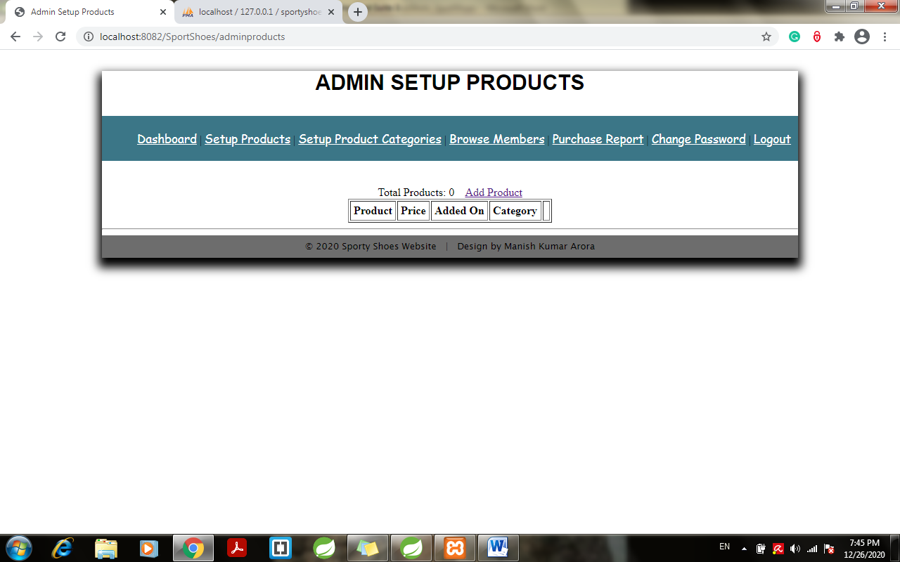

1. Click on add products> Redirects to Admin edit products page:

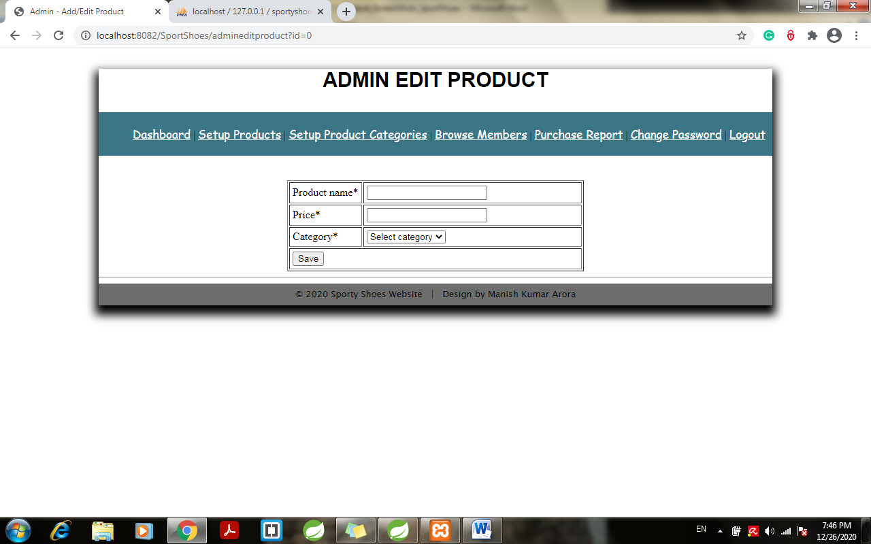

1. Enter Product Details > click on save:

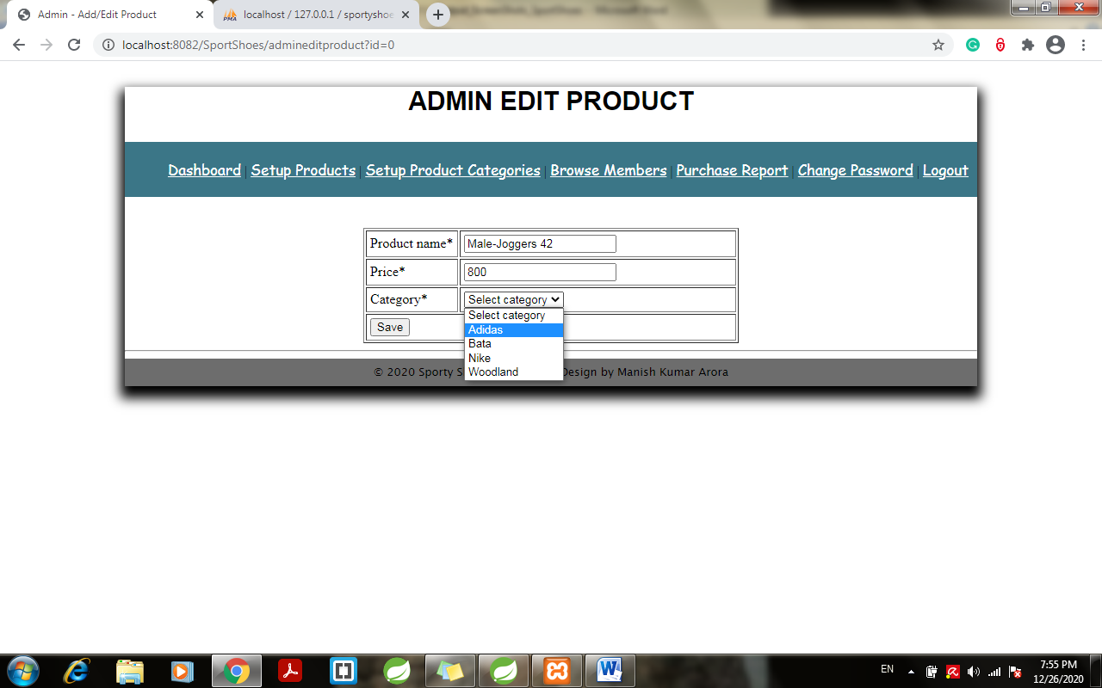

1. Click on save > redirects to admin set products page:

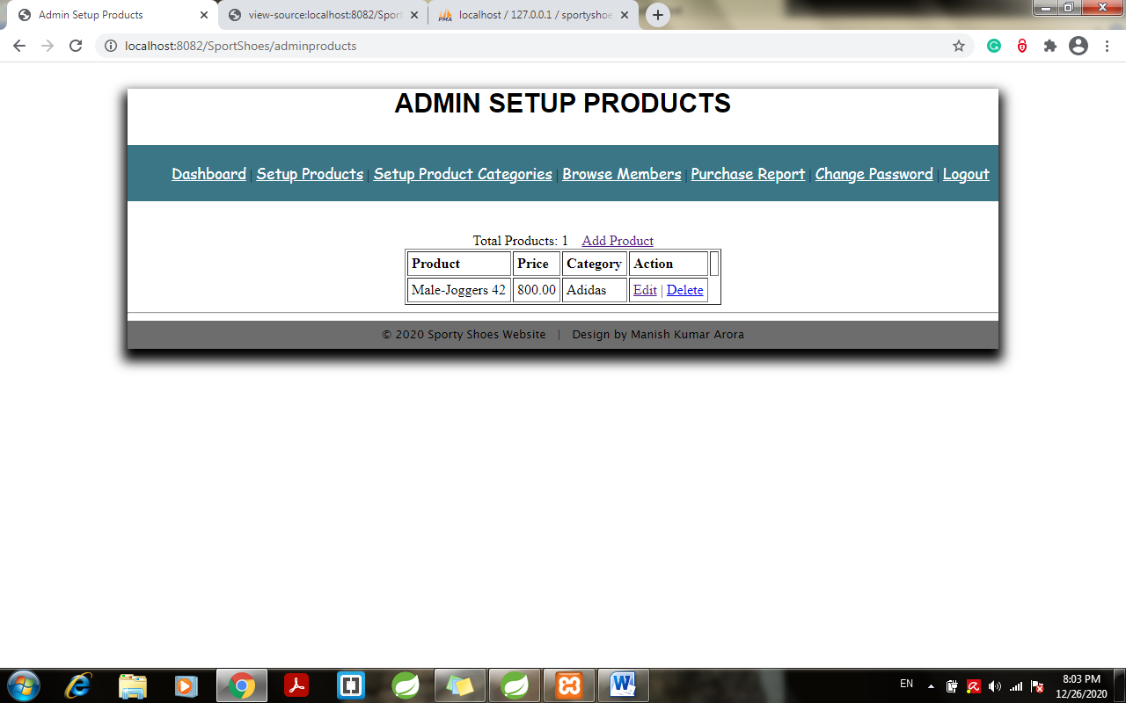

1. Click on edit and change the price:

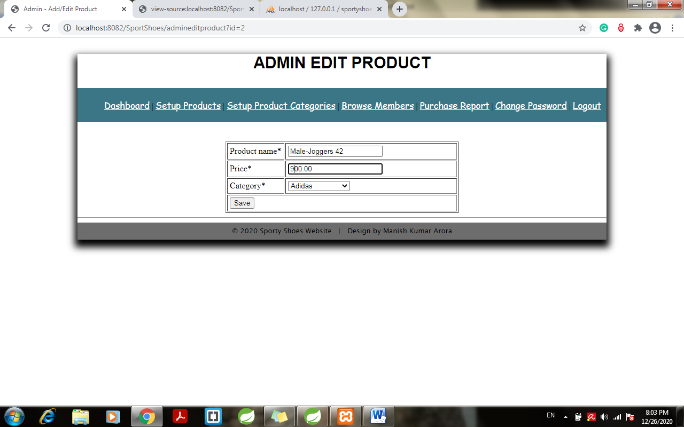

1. Click save to make the changes:

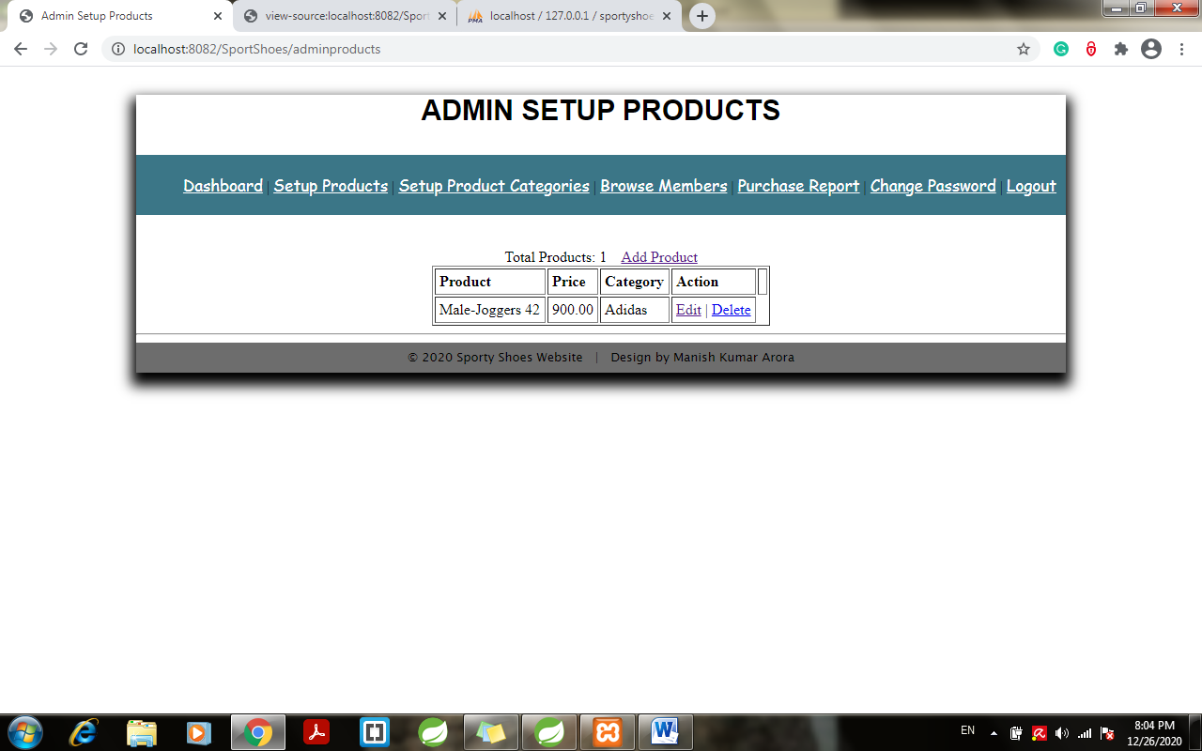

1. Click on change password to change the password:

New password now reset to admin12345 > click save:

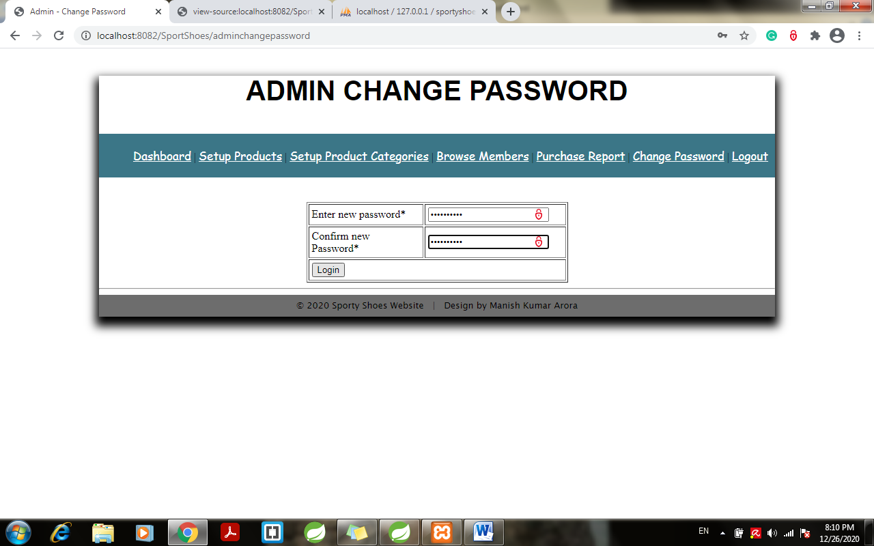

1. Click on save > redirects to admin login page:

Password change in table dynamically:

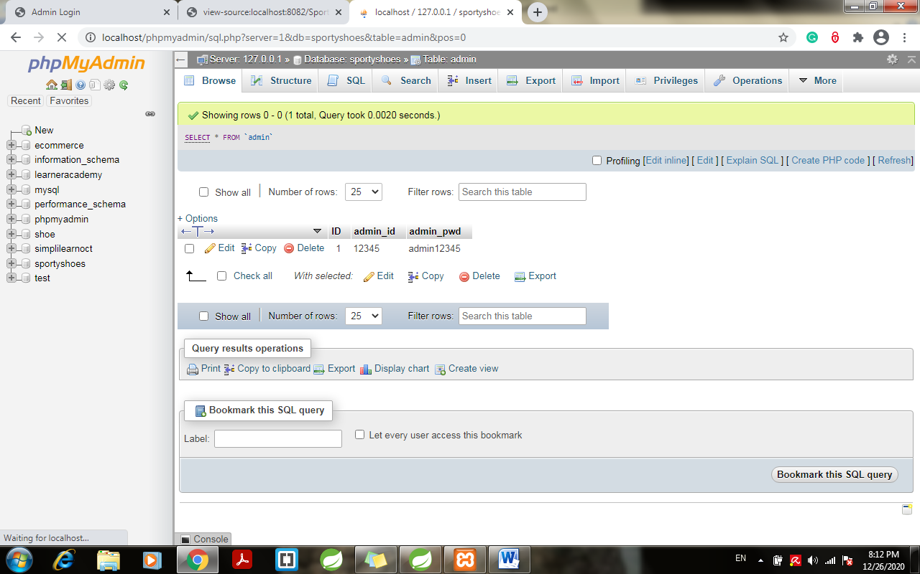

1. Try login with new password “admin12345”



1. Click on browse member to view the Registered members list:

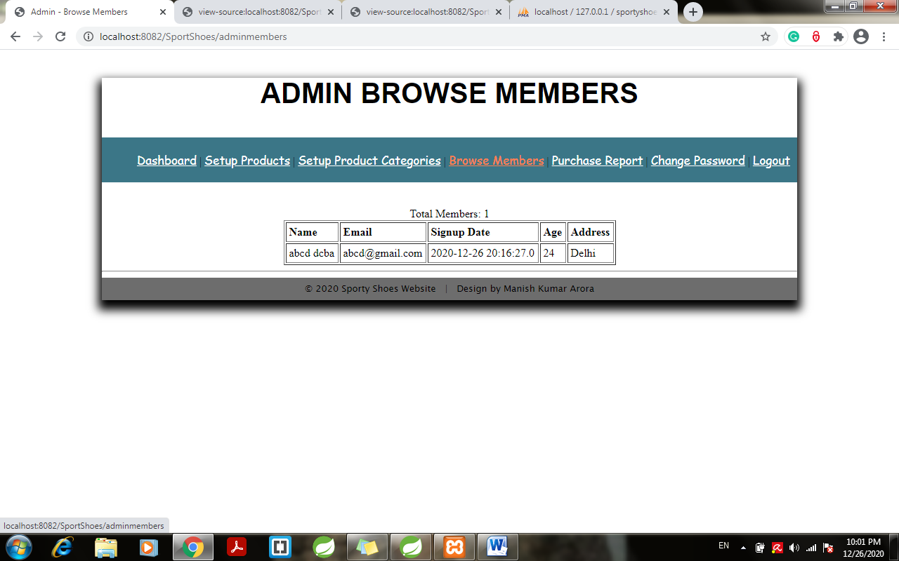

1. Click on purchase report to see the number of purchases done:

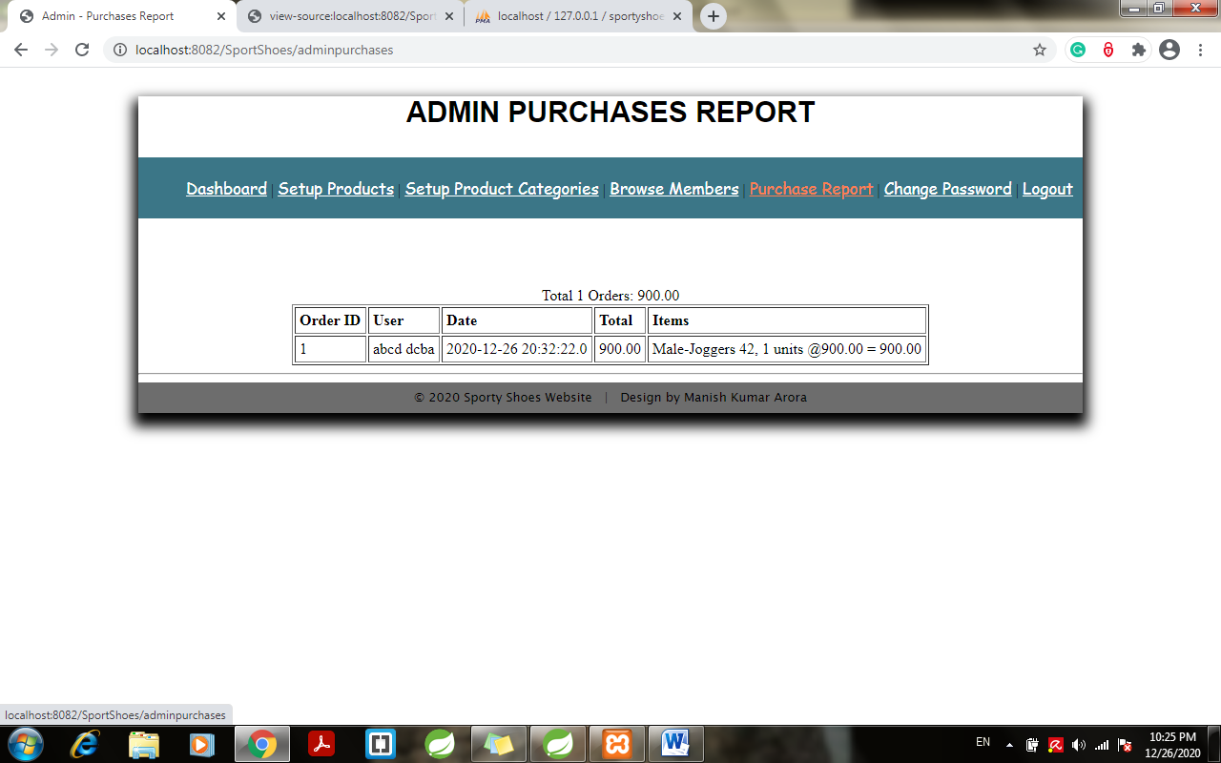

1. Click on logout > redirect to admin login page:

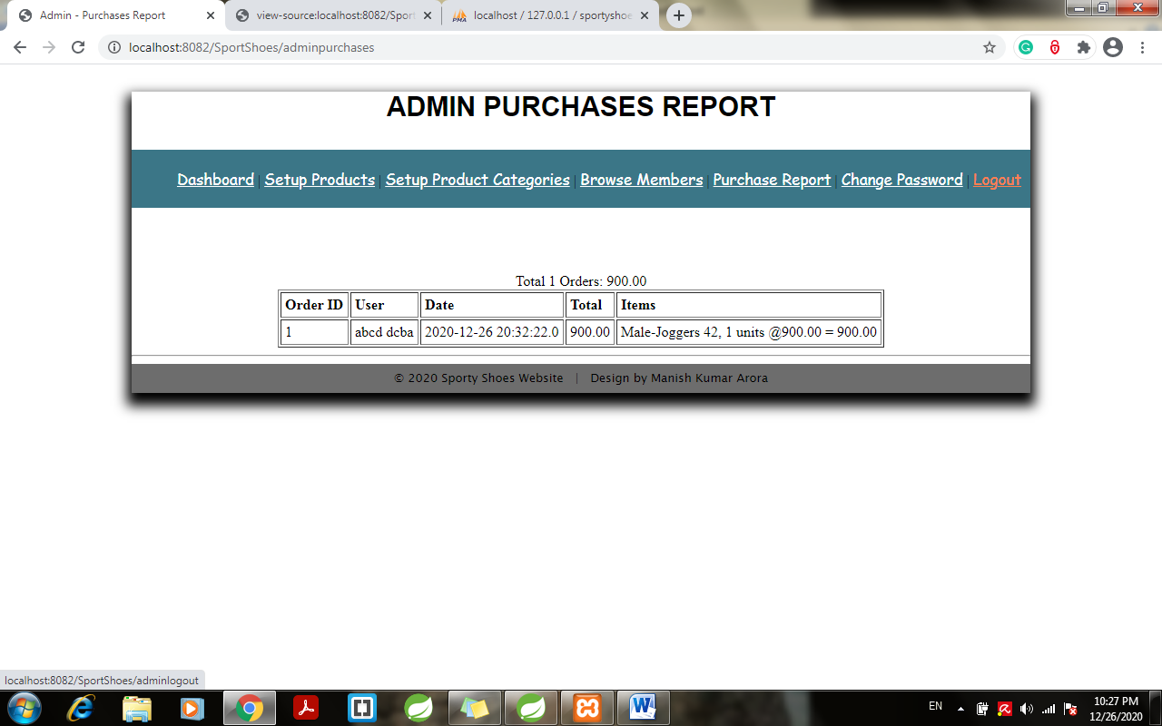

17.1 Logout and redirect to admin page:

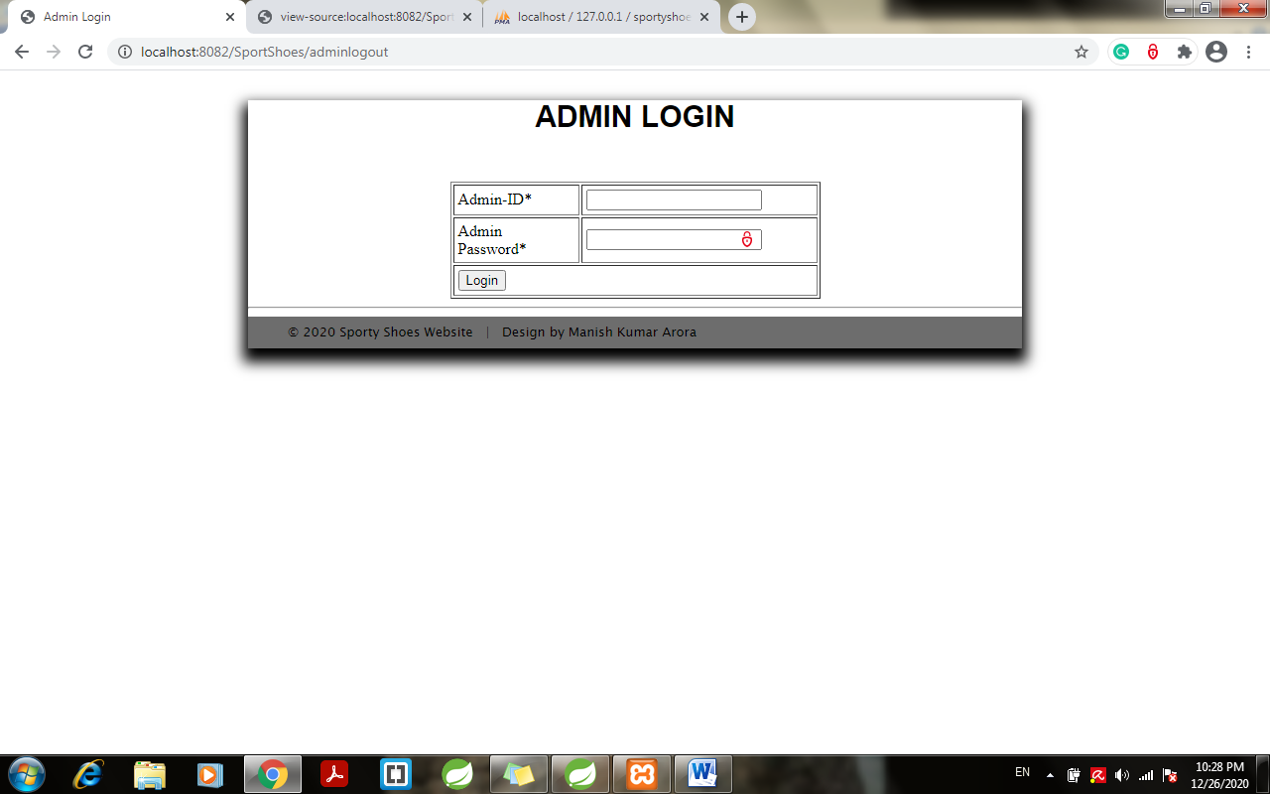

**Create a database in XAMPP: “SportyShoes”**

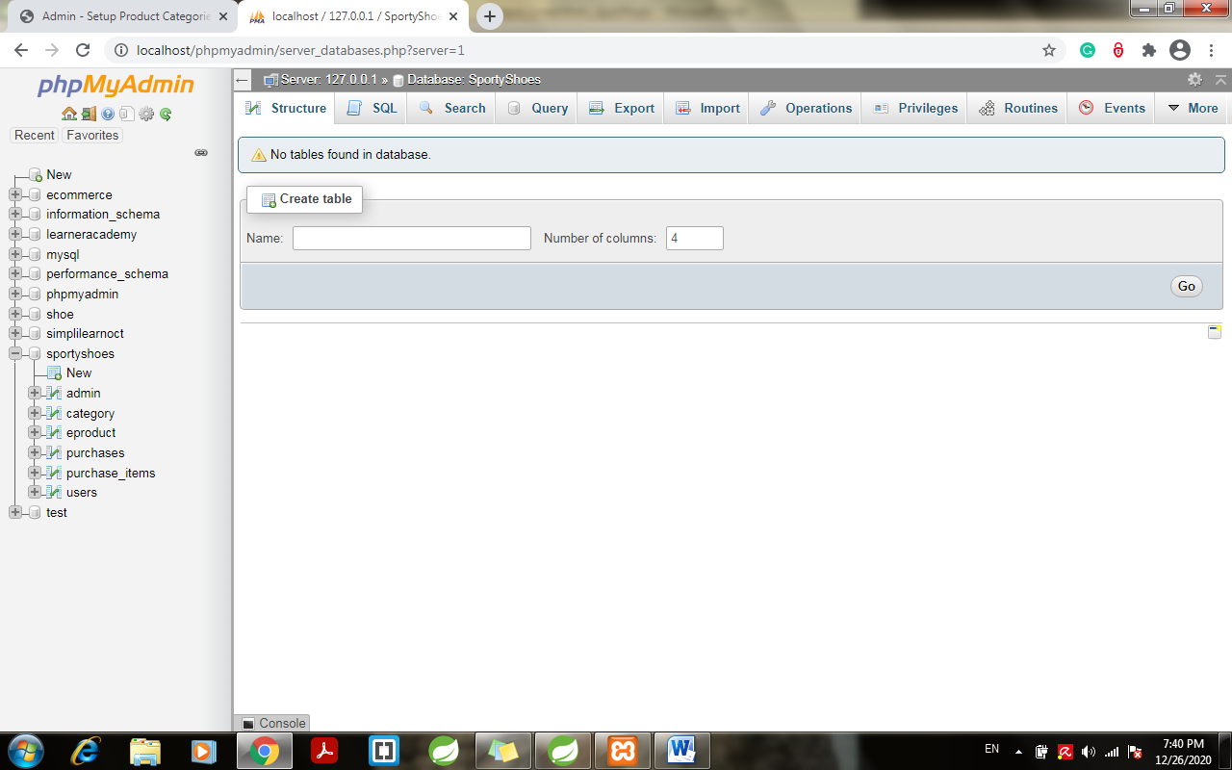

**Member Login:**

1. Click on login to get login page:

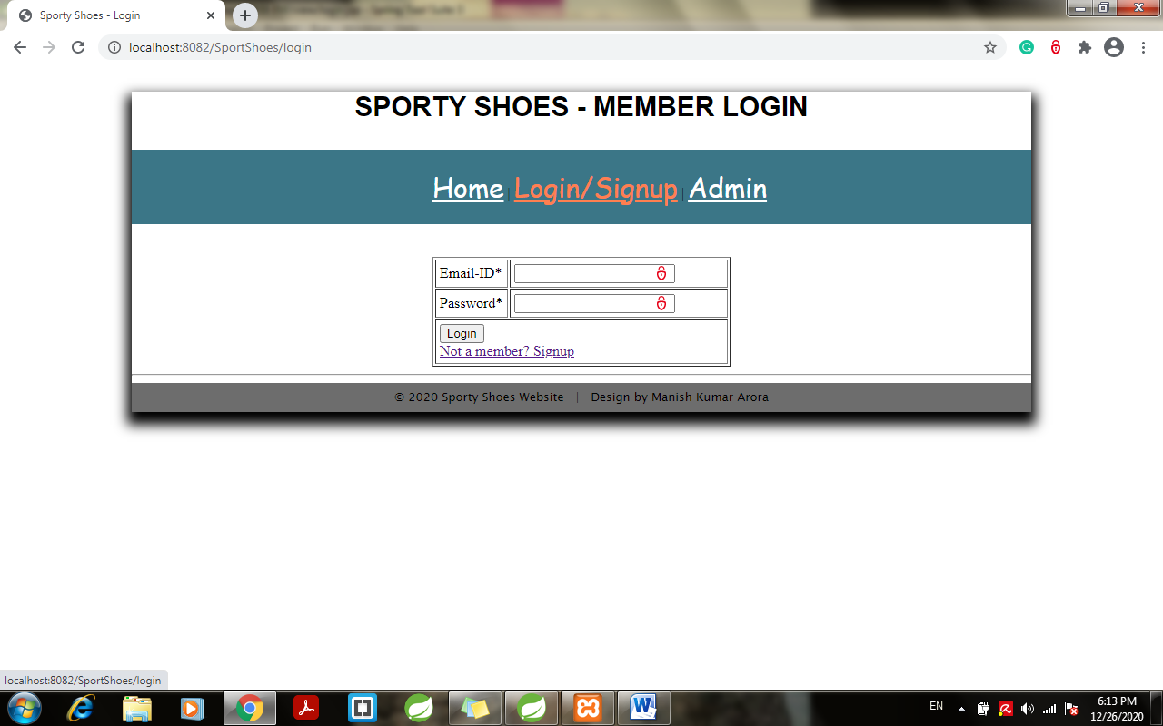

1. Enter user name and password and enter login:

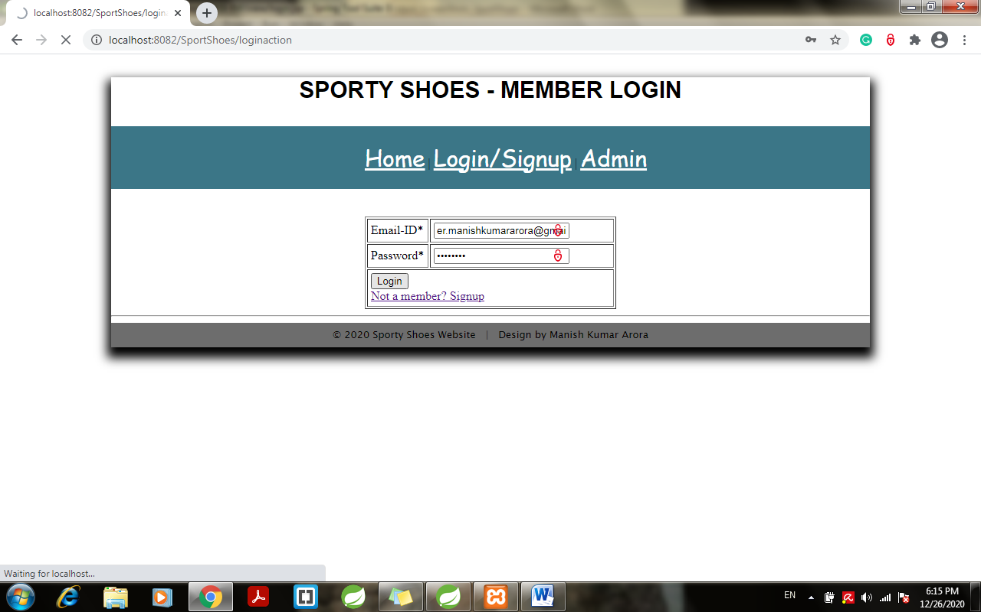

1. If not a member or entered incorrect credentials:

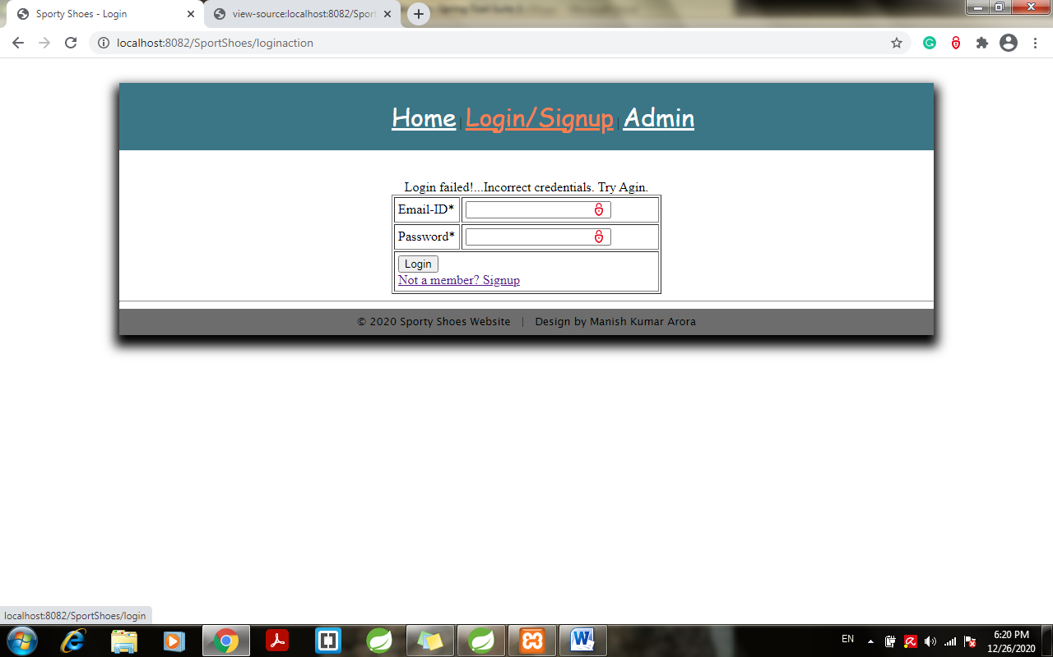

1. If not a member click on “Not a member?Signup”- will redirect to signup page:

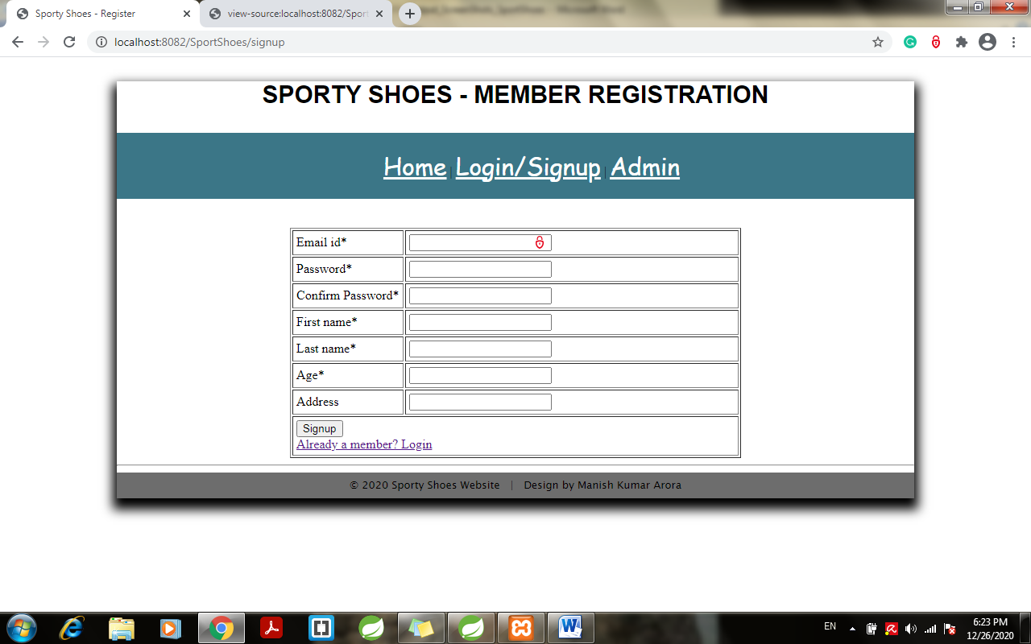

1. Enter the member details as below and click on sign up:

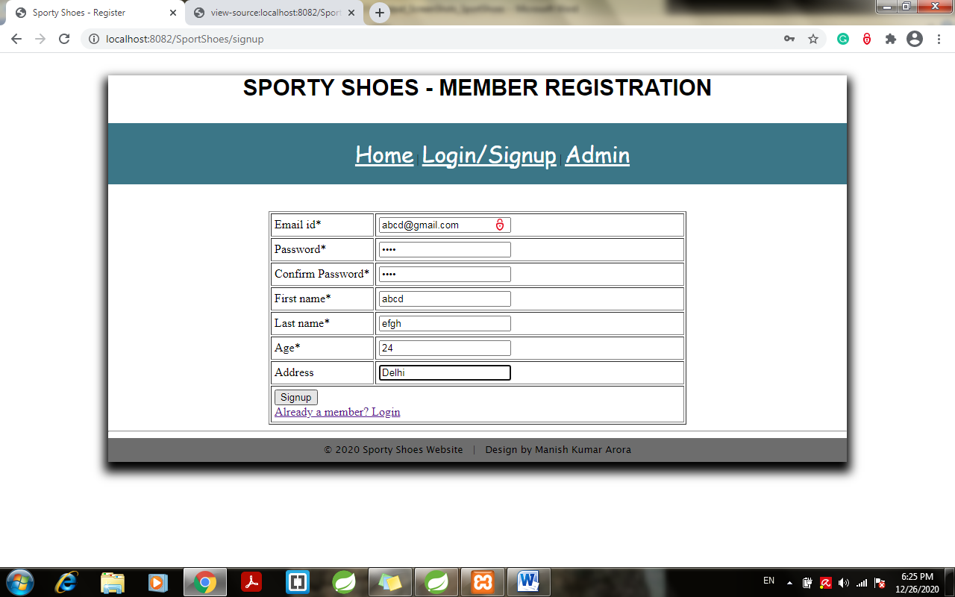

1. Successful registration > redirects to below page:

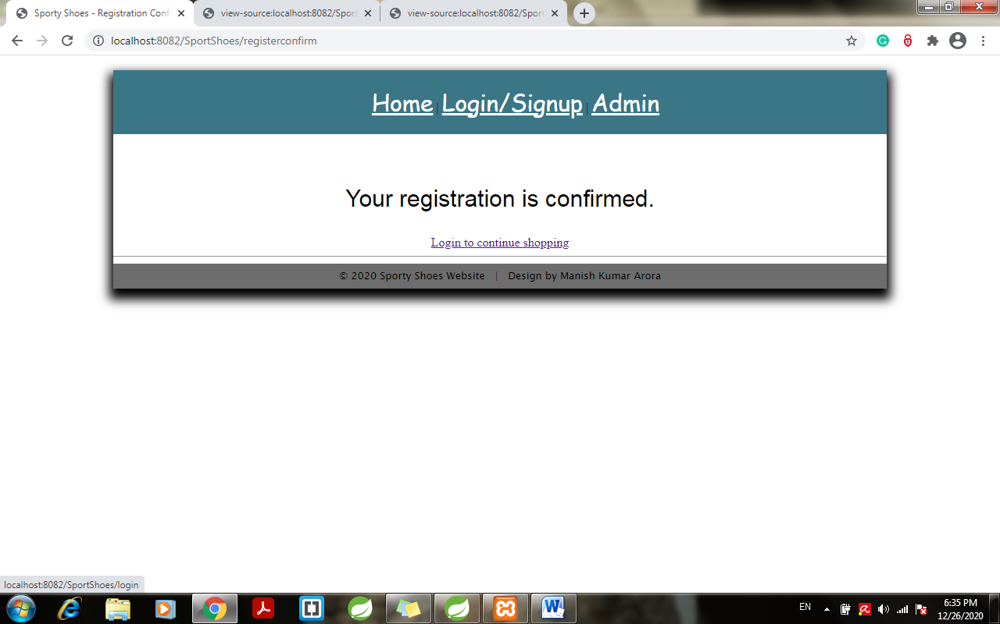

1. Check database > entries will be done dynamically for above registration:

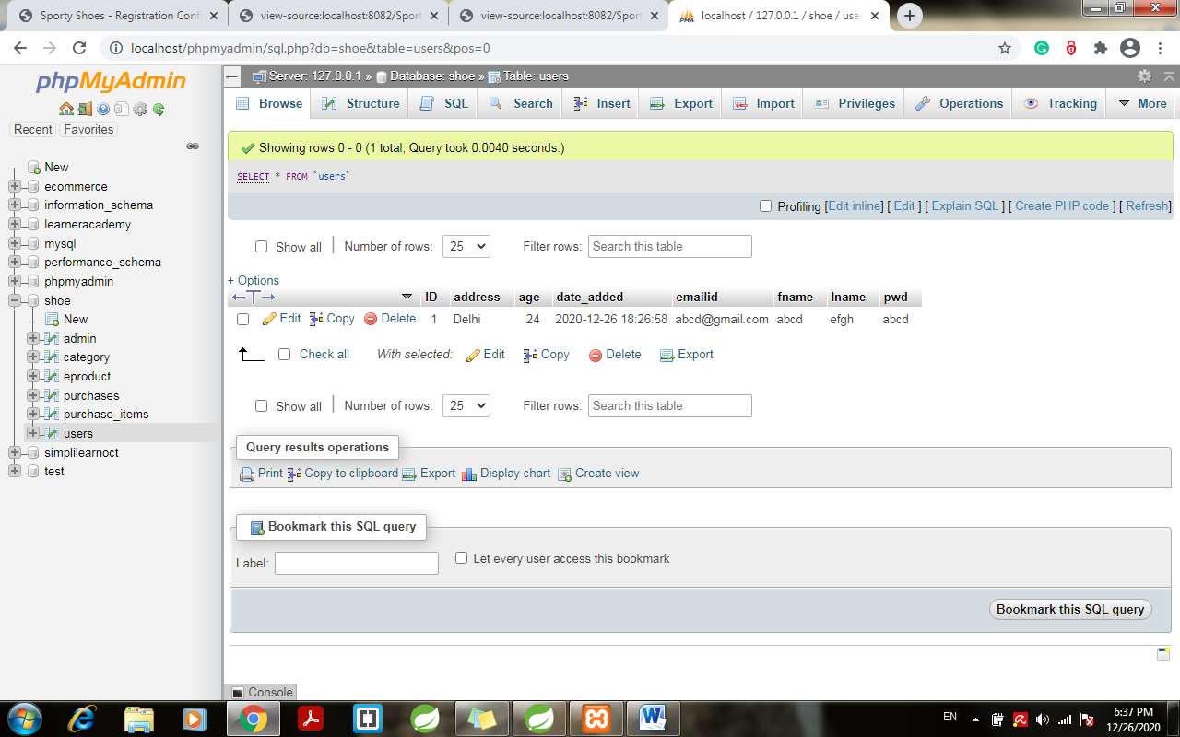

1. Click on “login to continue shopping” and enter the credentials and click on login:

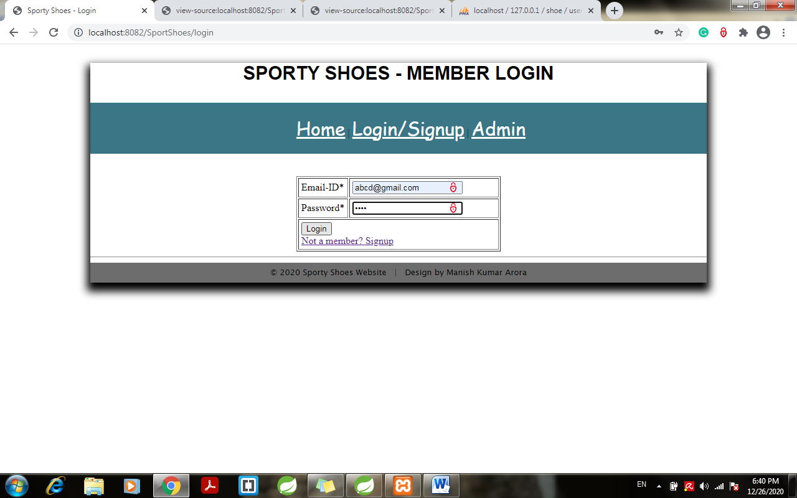

1. After login > click on home:

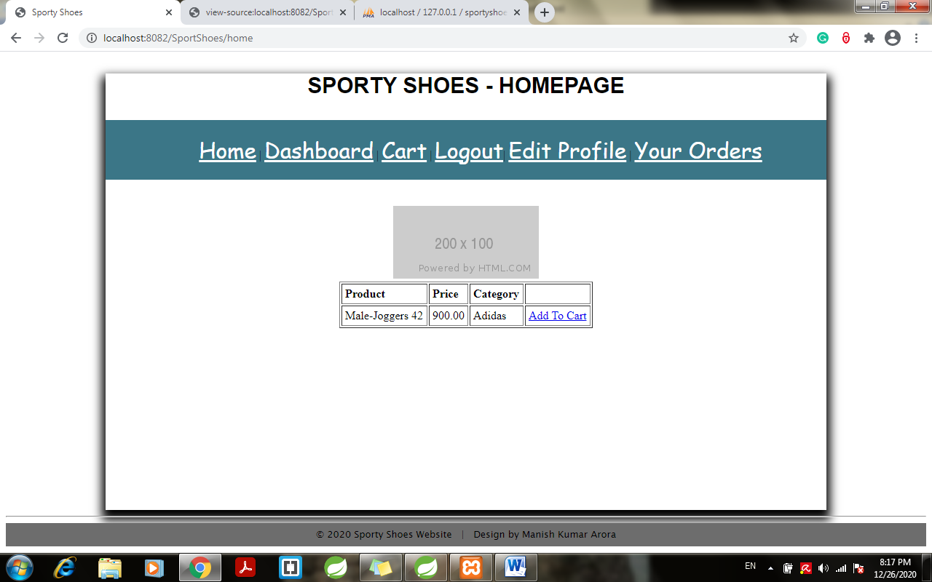

1. Product entered by admin displayed on Member’s home page> click on add to cart:

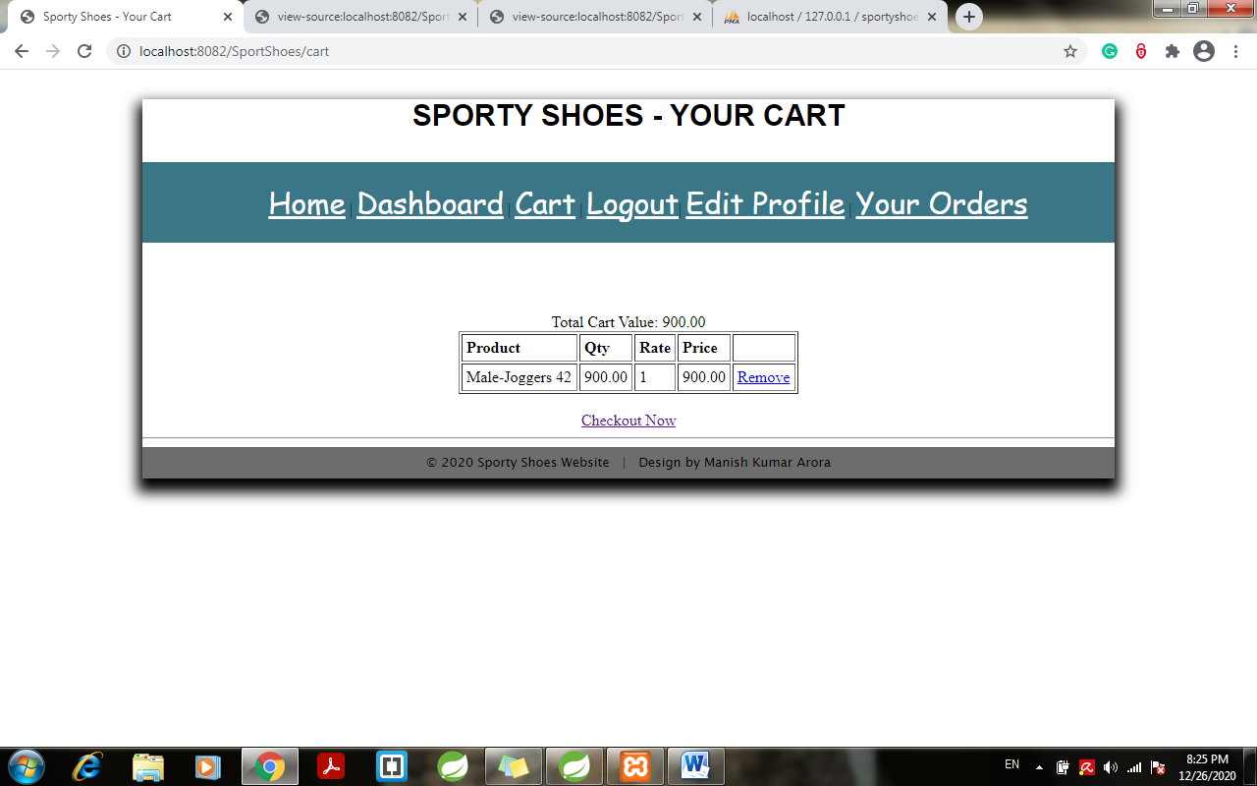

1. Click on checkout now> redirects to checkout page:

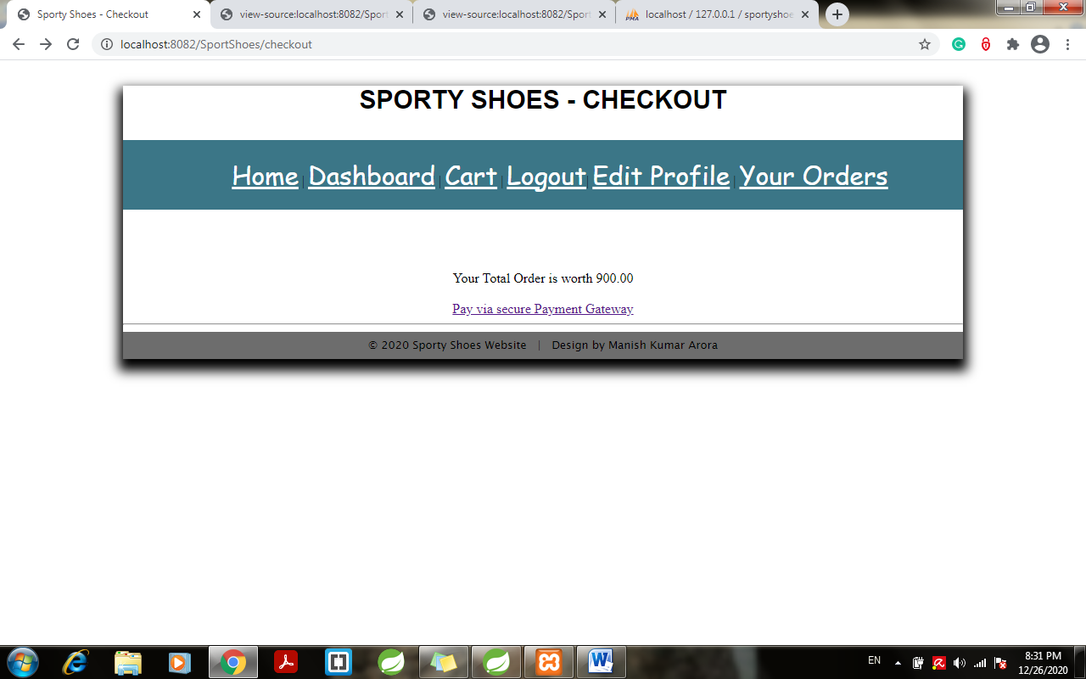

1. Click on pay via payment gateway > redirects to payment gateway page:

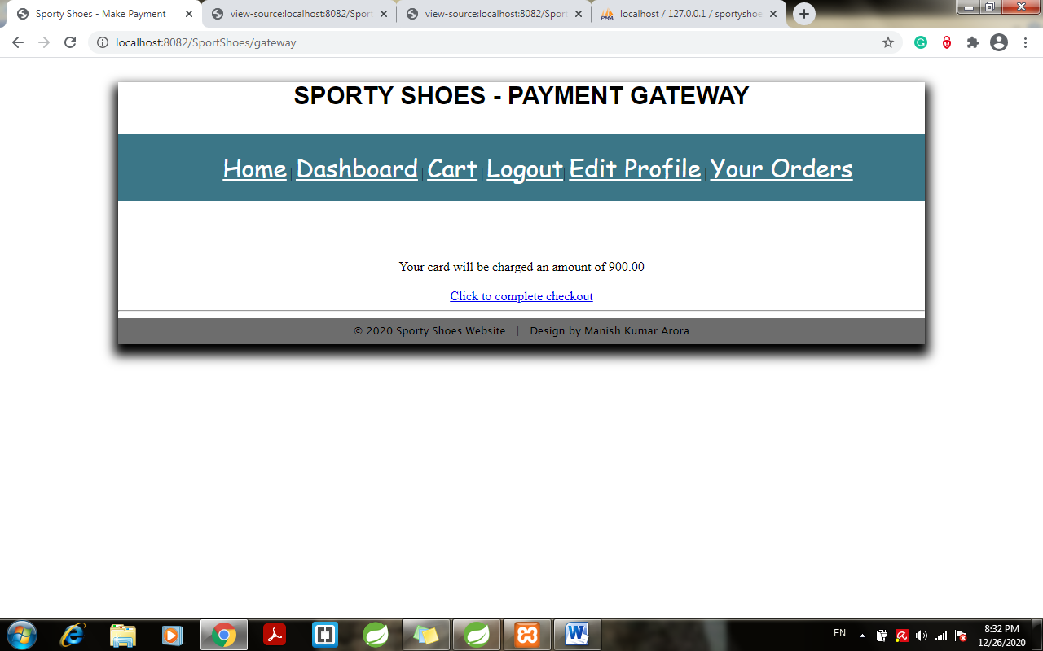

1. Click to complete checkout:

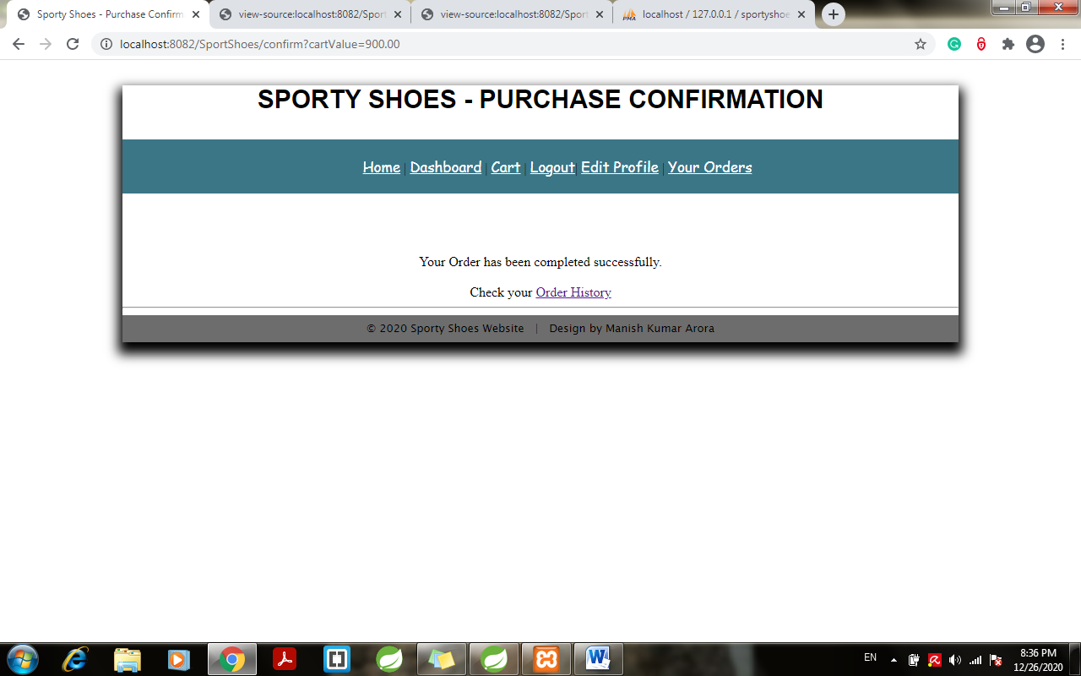

1. Click on order history to check your order:

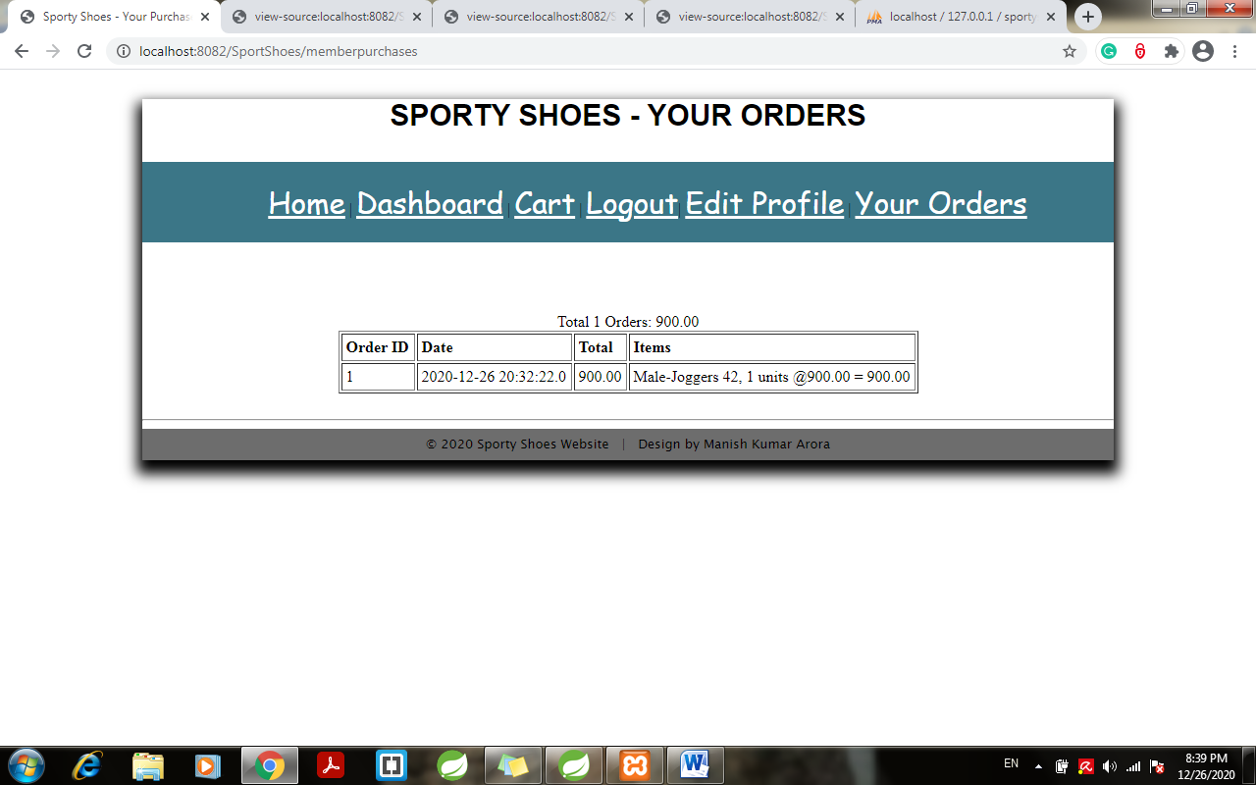

1. Click on edit profile to edit your name or password:

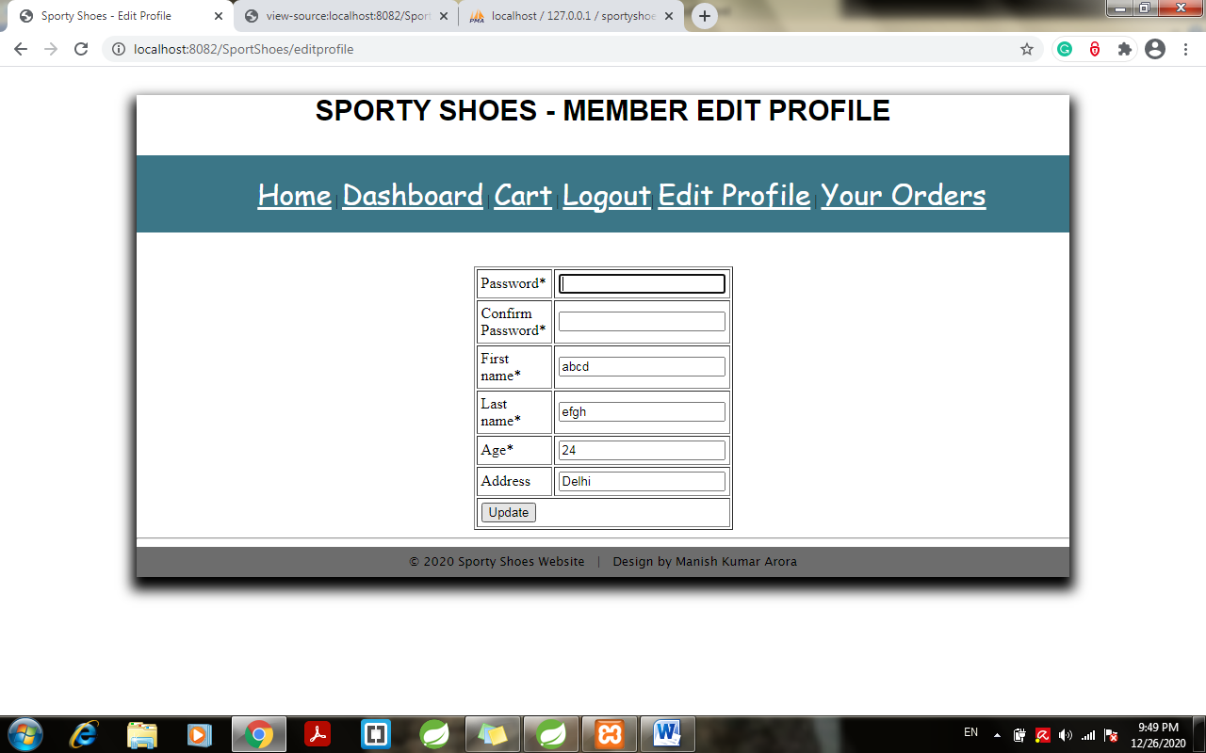

1. Try changing the password and last name > click on update and see the changes in table:

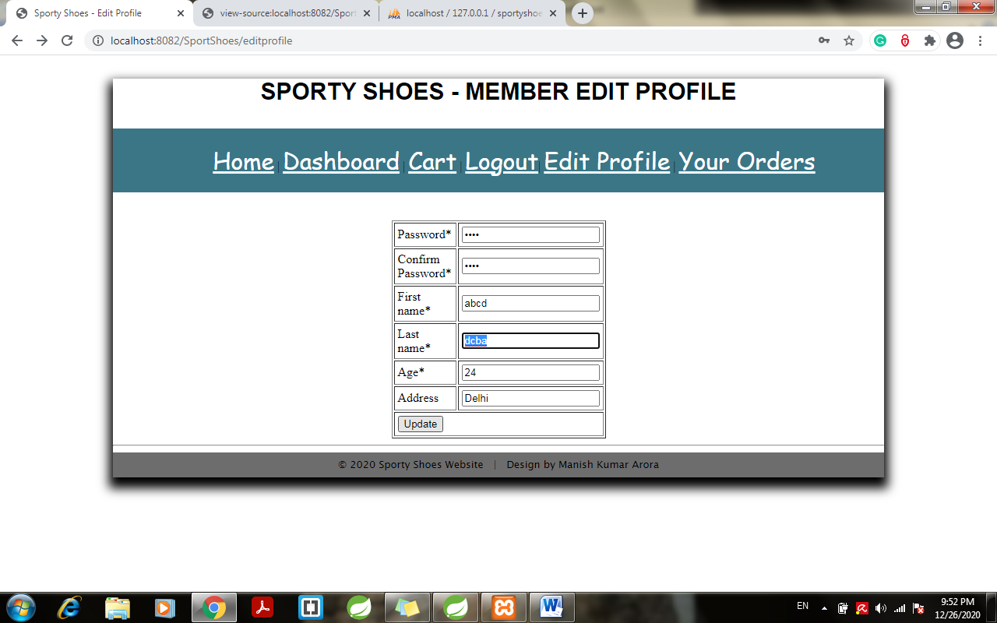

1. Changes reflecting in database:

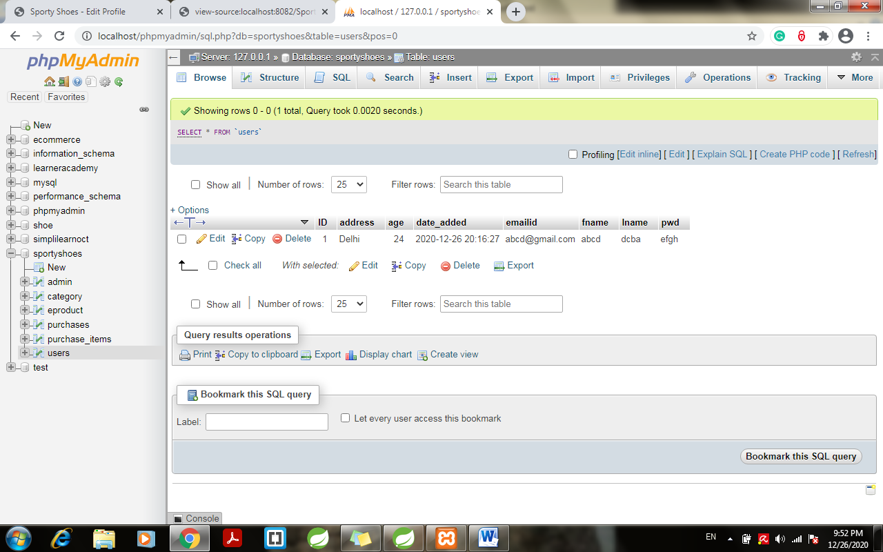

1. Click on logout> redirects to home page:

